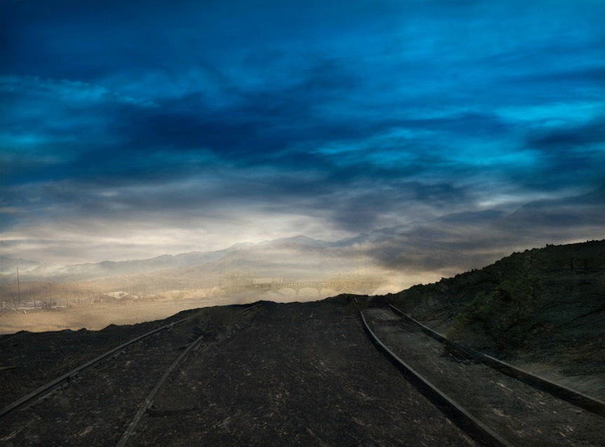

ABSTRACT
Elena Dorfman
-River 2, 2014-
This photo has some sort of tracks on top of the hill and if you close closely you can see the river at the bottom of the hill, the sky is bright blue and it starts to fade into white at the bottom. I love the way it focuses on the hill and then up to the sky. This photo gives peaceful vibes just by looking at it. I think the photographer likes to go far away to places just to take her unique shots, if you notice she also takes a photo of the river every year, I think she is trying to compare the river every year to see if it has improved or not over the years. She seems like a very smart photographer and I love her photos.
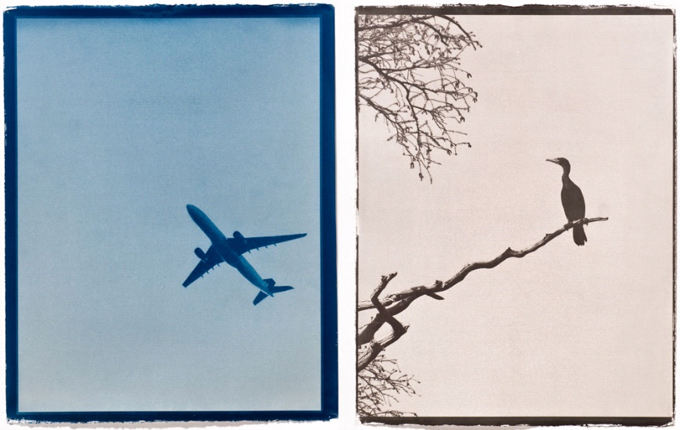

ALTERNATIVE PROCESSES
Alyssa Salomon
-Untitled-
These are two photos merged together, the first one is a picture of a plane and the other one is a picture of the bird. Both the plane and bird are always in the air, (both have wings). I think the meaning of this photo is to compare living and non-living things, just like this bird and plane and how they are both usually in the air.

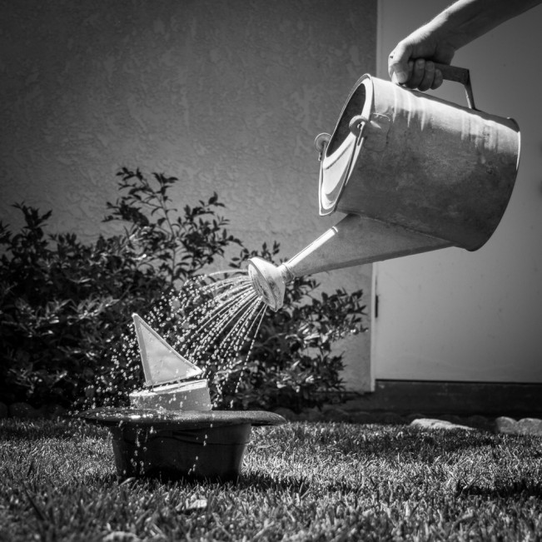

CONCEPTUAL
Brian Van de Watering
-Hatful of Rain-
This is a picture of garden water pot and it looks like they are watering a small boat inside a hat. I like how the picture was taken in black & white and the viewer sees the main point right away. The title connects to the picture because it is called “Hatful of Rain” and like I said before there is a small boat inside the HAT. This shows how creative the photographer is and how she has a little fun with her pictures.

